Candidate Number

Please stick the barcode label here.

Marker’s

Use Only
 |  | Marker No.
Question No. |  | Marks
1
2
3
4
5
6
7
8
9
10
11
12
Total

ARISTO EDUCATIONAL PRESS

HONG KONG DIPLOMA OF SECONDARY EDUCATION EXAMINATION

ECONOMICS PAPER 2
(Mock Test 28)

Question-Answer Book

Time allowed: 2 hours 30 minutes
This paper must be answered in English

INSTRUCTIONS
- After the announcement of the start of the examination, you should first write your Candidate Number in the space provided on Page 1 and stick barcode labels in the spaces provided on Pages 1, 3, 5, 7, 9, 11, 13, 15, 17, 19, 21 and 23.
- This paper consists of three sections, A, B and C. Answer ALL questions in sections A and B. Attempt any ONE question in section C.
- Write your answers in the space provided in this Question-Answer Book. Do not write in the margins. Answers written in the margins will not be marked.
- Supplementary answer sheets will be supplied on request. Write your candidate number, mark the question number box and stick a barcode label on each sheet, and fasten them with string INSIDE this book.
- No extra time will be given to candidates for sticking on the barcode labels or filling in the question number boxes after the ‘Time is up’ announcement.

Section A (44 marks)

1. A furniture manufacturing company is hiring part-time workers to provide door-to-door furniture assembly and disassembly services. The following is the advertisement of the company.

Part-time Workers Wanted!

Salary: Commission based on amount for each order + Tips from customers
*Flexible working hours*

(a) From the viewpoint of the owner of the furniture manufacturing company, explain TWO advantages of using the above wage payment method over time rate. (4 marks)

(b) After hiring more workers, given that the number of trucks transporting furniture remains the same, the company finds that the average number of orders received by workers decreases, and the marginal product of the workers drops. State the law that explains this phenomenon and briefly explain why such law can be applied in this case. (5 marks)

2. Refer to the following pricing arrangement of a boardgame café.

 | Fee
Half day pass | $100
Full day pass | $180

After the café implemented a rule requiring each customer to order at least one snack, the ratio of full day passes sold to half day passes sold has increased. Explain this phenomenon by the law of demand. (5 marks)

Please stick the barcode label here.

3. In order to improve people’s health, a country decides to impose a per-unit tax on producers for each unit of alcoholic beverages sold.

With the aid of a diagram, explain under what condition consumers will bear a larger tax burden than producers. (5 marks)

4. Music streaming platforms such as Spotify allow subscribers to listen to music online. Some platforms also allow non-subscribers to listen to music free of charge with advertisements being played in between.

(a) Explain whether the music played on music streaming platforms is a public good. (3 marks)

(b) Explain whether the free service that non-subscribers enjoy on the music streaming platforms is a free good. (2 marks)

Please stick the barcode label here.
5. The table below shows the balance sheet of a banking system. Suppose the banks hold $1,000 excess reserves and the public do not hold cash.

Assets ($) | Liabilities ($)
Reserves 3,000  Loans 5,000 | Deposits 8,000

(a) Calculate the required reserve ratio. (1 mark)

(b) Suppose someone withdraws $1,500 from the banking system and holds it in cash.

(i) Explain whether the monetary base changes. (2 marks)

(ii) Calculate the maximum possible amount of money supply. Show your working. (3 marks)

6. Country A and Country B each possess 90 units of resources. The following table shows the number of resources required by the two countries for the production of juice and bread.

 | 1 unit of juice | 1 unit of bread
Country A | 27 units | 9 units
Country B | 15 units | 6 units

(a) Which country has a comparative advantage in producing juice? Explain. (3 marks)

(b) Find the total output of juice and bread of the two countries after they completely specialise their production. (2 marks)

(c) The juice-exporting country exports 5 units of juice in exchange for 14 units of bread. Calculate the total gain from trade for the juice-exporting country. (3 marks)

Please stick the barcode label here.
7. The table below shows the current account data of Hong Kong in 2018 and 2019.

 | 2018 |  | 2019
 | Debit  (HK$ million) | Credit  (HK$ million) | Debit  (HK$ million) | Credit  (HK$ million)
Exports of goods |  | 4,453,350 |  | 4,255,098
Imports of goods | 4,706,347 |  | 4,375,619
(Source: Census and Statistics Department, HKSAR Government)

(a) Describe and explain the change in Hong Kong’s current account data in the above table. (2 marks)

(b) An economist stated that the depreciation of the US dollar against a basket of currencies over the above period was a factor contributing to the change in the imports of goods. Based on the above information, justify his statement. (4 marks)

END OF SECTION A

Section B (60 marks)

8. Since 2020, many mask factories have been set up in Hong Kong to produce masks.

(a) Suggest ONE possible reason to explain why the market structure of mask factories in Hong Kong is NOT perfectly competitive. (2 marks)

(b) Suppose the price of raw materials for masks has decreased. With the aid of a diagram, explain under what condition the total revenue of the mask factories would decrease. (7 marks)

(c) Give ONE reason to explain why the contribution of these mask factories to Hong Kong’s gross domestic product might be less than their sales revenue of the current year. (2 marks)

(d) Wearing a mask can effectively prevent an individual from contracting viruses and from spreading viruses to others. Explain how the behaviour of wearing a mask may involve externality.
(3 marks)

Please stick the barcode label here.

Price level
Figure 1

SRAS₀

E

LRAS₀

AD₀

Aggregate output
0

9. Figure 1 shows the AS-AD diagram of economy A. Point E is the original short run equilibrium of the economy.

(a) Explain if there is an inflationary (output) gap or a deflationary (output) gap. (2 marks)

Suppose the government wants to restore the economy to its long run equilibrium by raising the salaries tax rate or imposing a contractionary monetary policy.

(b) With the aid of the above diagram, explain how a contractionary monetary policy can help restore economy A to its long run equilibrium. (7 marks)

(c) Briefly discuss ONE advantage and ONE disadvantage of raising the salaries tax rate for economy A as compared to imposing a contractionary monetary policy. (4 marks)

(d) Other than the above policies, suggest ONE policy that affects the short run aggregate supply that can help restore economy A to its long run equilibrium. Briefly explain your answer. (2 marks)

Please stick the barcode label here.

Please stick the barcode label here.
10. Ocean Park is one of the theme parks in Hong Kong, attracting many visitors every year. The public has raised concerns over its financial situation. Some worry that it might go bankrupt.

Source A: An introduction to Ocean Park
Located on the southern side of Hong Kong Island, Ocean Park is operated by the Ocean Park Corporation and is one of the most popular attractions for local and overseas tourists. The park provides marine-based attractions and thrill rides, and also raises different species of insects, fish, birds and marine mammals for the appreciation of its visitors. It is an educational theme park that provides elements of entertainment, education and conservation.
(Source: Official webpage of Ocean Park)

Source B: A news report about the opening of Ocean Park Water World
Ocean Park Water World officially opened on 21 September, 2021. It is Asia’s first all-weather, year-round waterfront water park. It has indoor and outdoor play facilities.

On the opening day, adult and child fares for the Water World were $320 and $225 respectively. The Water World adopts dynamic pricing, where prices vary according to seasonality and days of the week. On public holidays, the fare can rise to more than HK$400. The Park expects the Water World to bring over HK$300 million in revenue every year.
(Source: various newspapers)

Source C: Attendance and admission income for Ocean Park between the fiscal year of 2019/20 and 2020/21

(Source: Ocean Park Corporation Annual Report)

Source D: A news report about the provision of government relief fund to Ocean Park Corporation
Ocean Park has suffered from persistent losses between 2016 and 2019. Due to the COVID-19 epidemic, the number of tourists has dropped, and people have avoided going out. Ocean Park has even been closed several times between 2020 and 2021, which seriously affected the park’s revenue. Ocean Park Corporation was facing huge financial challenges in operation and development.

The government has provided the corporation with a relief fund to support the operation of the park and repay the company’s commercial loans to prevent the park from going bankrupt.
(Source: various newspapers)

Source E: Views on Ocean Park’s possible bankruptcy
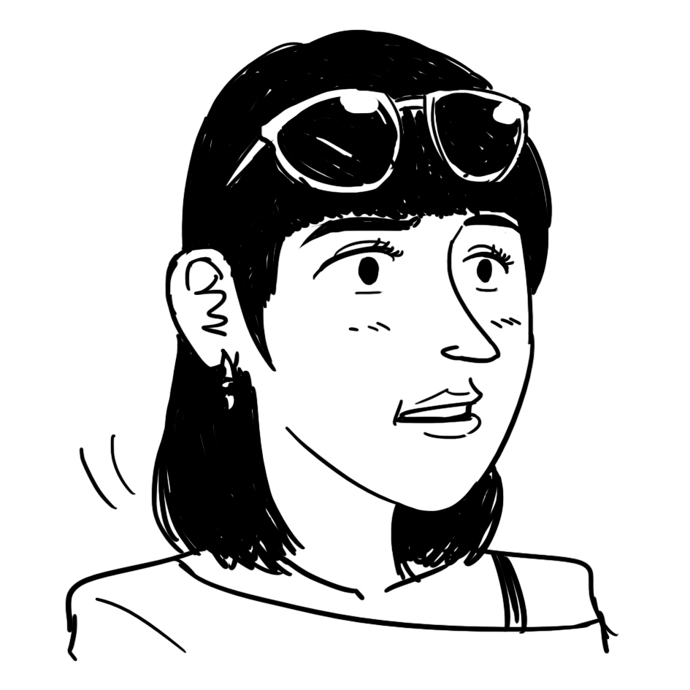  A Mainland tourist | My son likes to visit Ocean Park very much. If the park closes down, we may not visit Hong Kong again!
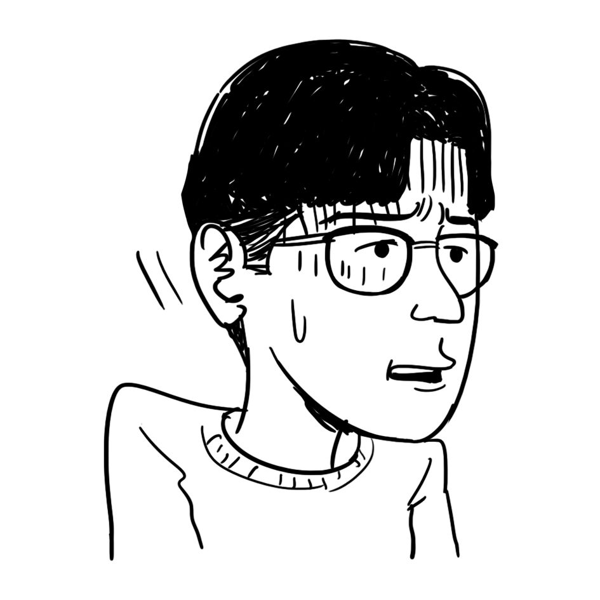  A staff member of Ocean Park | Ocean Park employs thousands of workers. If it closes down, we will lose our jobs.
  A district council member | Tourists may dine in the restaurants nearby after they visit Ocean Park. The closing down of Ocean Park may affect their revenue.
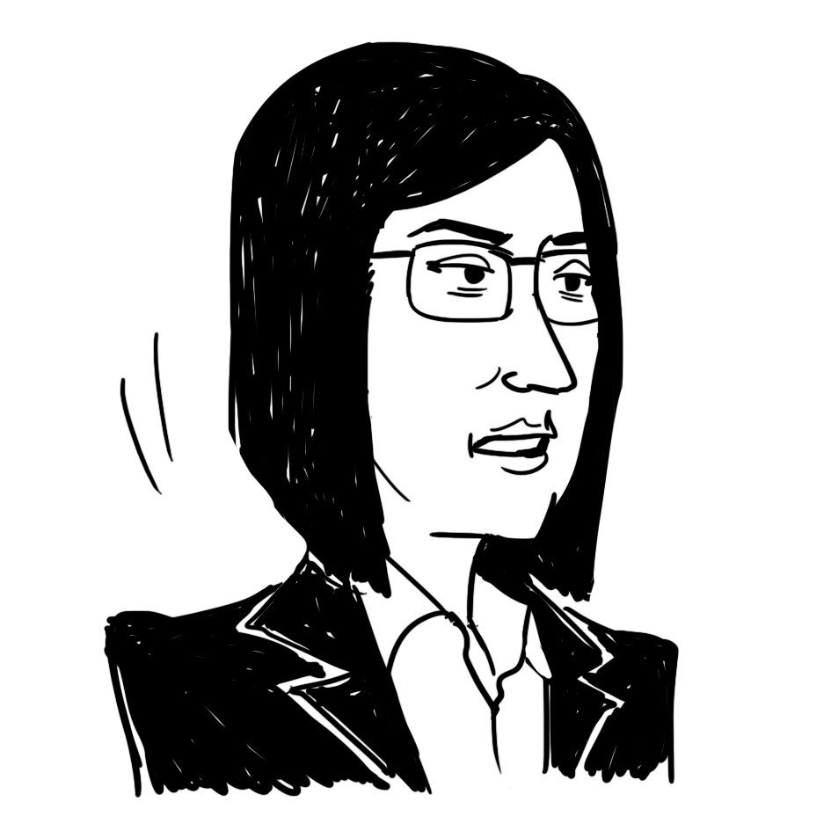  An accountant | Ocean Park Corporation may suffer a loss in the future and need government grants again.

Please stick the barcode label here.

(a) Refer to Source A. Which type of factor of production do animals raised in Ocean Park belong to?
(1 mark)

(b) Refer to Sources A and B. Which type of expansion does Ocean Park Corporation developing the Water World belong to? Explain. (2 marks)

(c) Refer to Source B.

(i) Under the dynamic pricing, explain whether the opportunity cost of tourists visiting the Water World on weekdays is necessarily lower than that on weekends. (4 marks)

(ii) Which function of price is illustrated by the dynamic pricing? Explain. (2 marks)

(d) Suppose the admission fee of Ocean Park in the fiscal year of 2019/20 and 2020/21 did not change. Refer to Sources C and D. Explain the change in the admission income with the aid of a diagram. (8 marks)

For part (e), candidates are required to present their answer in essay form. Criteria for marking will include the use of sources and economic theories, relevant content, logical presentation and clarity of expression.

(e) With reference to the above sources and your own knowledge in Economics, discuss the effects of the closing down of Ocean Park on Hong Kong, including:
- aggregate output,
- fiscal balance,
- unemployment rate, and
- other economic variable(s).
(14 marks)

Please stick the barcode label here.
END OF SECTION B

Section C (16 marks) Answer any ONE question.

11. Lok’s Amusement Park is the only indoor amusement park in Country A. It adopts uniform pricing. Figure 2 shows its demand curve and marginal cost curve.

(a) Indicate the marginal revenue curve (MR), the profit-maximising output level (Q_{M}) and the price (P_{M}) of Lok’s Amusement Park in Figure 2. (3 marks)

(b) With the aid of Figure 2, explain why Lok’s Amusement Park adopting uniform pricing will lead to a deadweight loss. (2 marks)

(c) Suppose the marginal cost of Lok’s Amusement Park increases and the park does not change its output and price. With the aid of Figure 2, explain whether economic efficiency will be affected. (3 marks)

(d) The following is the pricing arrangement of Lok’s Amusement Park:

Weekdays  Adult: $80 per hour  Child aged 1-12: $130 per hour | Weekends  Adult: $150 per hour  Child aged 1-12: $200 per hour

Explain if the difference in prices between weekdays and weekends constitutes price discrimination.
(3 marks)

(e) It is reported that Lok’s Amusement Park makes an agreement with its potential competitor that if Lok’s Amusement Park does not expand its business to Country B, its potential competitor will not expand its business to Country A. Which anti-competitive behaviour does Lok’s Amusement Park engage in? List TWO possible motives for it. (3 marks)

(f) Some citizens criticise that there is only one indoor amusement park in Country A and that Lok’s Amusement Park may be involved in anti-competitive behaviour. Give ONE reason to explain why the fact that Country A has only one indoor amusement park is not necessarily anti-competitive. (2 marks)

Unit price
MC₀
0
Figure 2
D
Quantity
Please stick the barcode label here.

Please stick the barcode label here.
100
A
B
Good Y
Good X

Figure 3
P_{A}
PPF_{A}

0

12. Refer to Figure 3. PPF_{A} is the production possibility frontier of Country A. P_{A} is the production point of Country A under autarky. The slope of the dotted line AB is the world price of good X.

(a) Explain why the production possibility frontier of Country A is concave to the origin. (2 marks)

(b) Indicate, in Figure 3, the opportunity cost of producing good X. Explain whether Country A has a comparative advantage in producing good X.
(Hint: you may add a straight line at P_{A}.) (4 marks)

(c) Suppose Country A engages in trade. In Figure 3,

(i) indicate the production point (P_{T}) and consumption possibility frontier (CPF_{A}) of Country A after trade. (3 marks)

(ii) indicate the consumption point (C_{T}) of Country A after trade. Explain why Country A will gain after trade. (2 marks)

(iii) indicate the export volume of Country A. (1 mark)

(d) The following table shows some data of Country A before and after opening up to trade.

 | Before trade | After trade
Human Development Index (HDI) | 0.62 | 0.75
Life expectancy at birth | 74 | 74

(i) Give ONE possible reason to explain the change in HDI after trade. (2 marks)

(ii) Despite an increase in HDI, residents of Country A think that their living standard has decreased. Give TWO possible reasons to explain their view. (2 marks)

Please stick the barcode label here.
END OF PAPER

